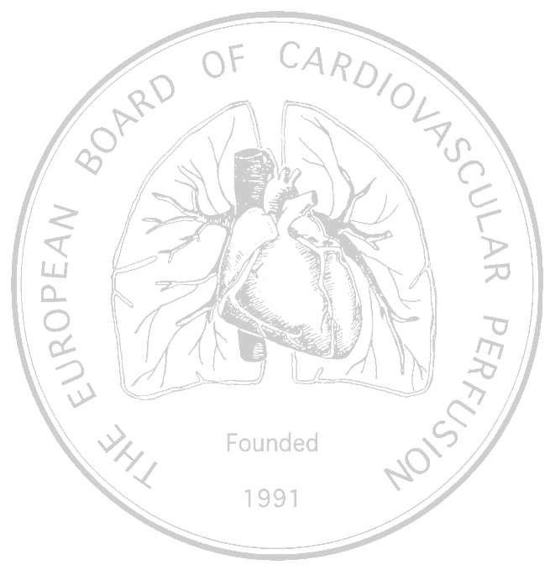PRELIMINARY PROGRAMME

***15th European Conference on***

***Perfusion Education and Training***

**Saturday, 3rd October 2015**

**0900 - 1730**

**Amsterdam, The Netherlands**

**Forum Room, ground level**

**RAI Conference Centre**

***Strategies in Adult &***

***Pediatric Perfusion***

***The European Board of Cardiovascular Perfusion***

### Chairman: Prof. Alexander Wahba MD (Norway)

### General Secretary: Mr. Frank Merkle Dipl. med. Päd (Germany)

Organizer: Judith Horisberger (Switzerland)

Registration: Damien McCann (Ireland)

Treasurer: Else Nygreen (Norway)

Webmaster: Heinz Weitkemper (Germany)

Scientific committee: Judith Horisberger (Switzerland)

Leen Vercaemst ( Belgium)

Carole Hamilton (Germany)

Inês Figueira (Portugal)

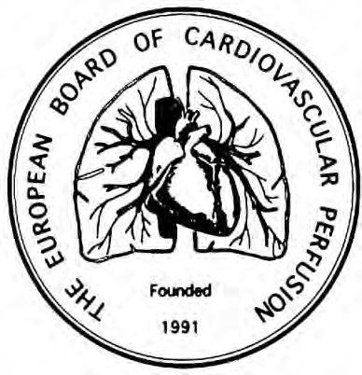

[**www.ebcp.org**](http://www.ebcp.org/)

##### SESSION MODERATORS:

Alexander Wahba MD, PhD

Dept Cardio-thoracic Surgery

Trondheim, Norway

EBCP Chairman

Gudrun Kunst MD PhD

Cardiac anesthetist

Kings College

London UK

EACTA delegate

Adrian Bauer

Chief perfusionist

Herzzentrum Coswig

Coswig, Germany

EBCP Vice General Secretary

Jan Schaarschmidt

Senior perfusionist

HerzzentrumCoswig

Coswig, Germany

EBCP delegate

Carole Hamilton

Chief Perfusionist, Lifesystems / Specialty Care Vogtareuth

Schoen Clinic, Germany

EBCP Academic Committee

Leen Vercaemst

Perfusionist, Coordinator Perfusion School Leuven

Leuven, Belgium

EBCP ELSO representative

Tomas Gudbjartsson MD.Ph.D

Landspitali University Hospital

Reykjavik, Iceland

EACTS representative

Frank Merkle Dipl.-Med. Päd

Akademie für Kardiotechnik

Deutsches Herzzentrum Berlin

EBCP General Secretary

Dalibor Zovko

Clinical Hospital Magdalena

Krapinske Toplice, Croatia

EBCP delegate

Darren Best

Clinical Perfusion Specialist & Senior Academic Lecturer

NESCOT, Surrey, UK

EBCP Delegate

## 09:00-09:10 “Welcome to Amsterdam”

**Speaker:**

### President, NESECC, The Netherlands Perfusion Society

### 

**0910-1050 Scientific Presentations**

Moderators Alexander Wahba MD, Gudrun Kunst MD

**10.50-11:20 Coffee break**

**11:20-13:00 Scientific Presentations**

Moderators Adrian Bauer, Jan Schaarschmidt

**13:00-14:00 Lunch**

**14:00-14:40 Poster presentations**

Moderators Carole Hamilton, Leen Vercaemst

**14.40-15:45 Scientific Presentations**

Moderators Tomas Gudbjartsson, Frank Merkle

**15:45-16:15 Coffee break**

**16:15-17:05 Scientific presentations**

Moderators Dalibor Zovko, Darren Best

**17:05-17:15 Closing speech** Frank Merkle

Time Speaker/title Page

**09:10-0930 Normunds Sikora** The proper delivery pressure for cardioplegic solution in neonatal cardiac

surgery- an investigation of biomechanical and structural properties in

neonatal and adult coronary arteries

**09:30-09:50 Kivanç Metin** Efficacy of minimized circuits on CPB in pediatric cardiac surgery

**09:50-10:10 Yves Durandy** Evaluation of the benefits and safety of miniaturized circuits on blood transfusion

on blood transfusion in < 10kg pediatric patients

**10:10-10:30 Kyriakos Anastasiadis** Modular minimal invasive Extracorporeal Circulation (MiECC) Systems as the standard practice for performing Cardiac Surgery

**10:30-10:50 Valerio Mazzei** Feasibility of utilization of miniaturized CPB during aortic valve surgery

including minimally invasive approach

**11:20-11:40 Robert Baker**

Transfusion, Independent of Anaemia is Associated with mortality after Cardiac Surgery: Multicentre Analysis using the perfusion Downunder Collaborative Database

**11.40-12:00 Timothy Jones**

The Role of Simulation in perfusion

**12:00.12:20 Andy Stone** Fusion Oxygenator Edinburgh retrospective Investigation in routine clinical use

**12.20-12:40 Mirko Belliato MD** vv-ECMO: the ‘LANDING monitor real time contribution’ for adequate patient’s respiratory function.

**12:40-1300 Sorin presentation**

**14:00-14:40 Poster session powerpoint presentations 23-30**

**14:40-15:00 Leen Vercaemst**Blood cell trauma in ECLS- The Role of Centrifugal Pumps

**15:00-15:15 Roberto Miceli**The application of the ECMO circuit in Neurosurgery

**15:15-15:30 Judita Andrejaitiene**

Postoperative Delirium in Patients after Cardiac Surgery: Incidence, Risk factors

And Outcome

**15:30-15.45 Deborah Castellani**FX 15

**16:15-16:35 Marc Lagny**Leucocytes and Lipid particles Filtration in suction blood during CPB: impact on Kidney Function evaluated with a monocentric prospective randomized study

**16:35-16:50 Anatole Kanevsky** Oxygenator Performance Characteristics in a 2.93m2 BSA patient – A case report

**16:50-17:05 Frank Merkle**

What is the risk of CPB?

Time **POSTER PRESENTATION** Speaker/title Page

**14:00-14:05 Monica Patricia Hernandez Abaunza**Comparative Study of Del Nido versus Custodiol Cardioplegia in

Adult Cardiac Surgery

**14:05-14.10 Jessica Dada**Challenges to Perfusion Practice following the Introduction of an Intra-aortic

Occlusion Device in a Centre with experience of Minimal Incision Cardiac Surgery

**14.10-14.15 Carole Hamilton**3/8” venous line without vacuum – what are the limits?

**14.15-14:20 James Ferguson**The Comparison of the gold standard blood gas to the real-time Spectrum

non-invasive blood gas monitoring system for maintaining the patients

physiological parameters during CPB

**14.20-14:25 Cinzia Casarotto**Separation of Extracavity Blood during coronary Surgery reduces Systemic

Inflammatory Response, Hemolysis, need for Transfusion and post-op hospitalization

**14:25-14:30 Anna Semenova**Somatic NIRS-Oxymetry may reflect the Adequacy of Perfusion in Adults

**14:30-14.35 Aleksandra Temelkovska**Aortic valve surgery using only blood for cardioprotection

**14:35-14:40 Altia Crous**An Evaluation and comparison of Metabolic and Clinical changes in patients with Acute Coronary Syndromes Undergoing On-pump and Off-pump CABG